Marketing to Customers

A Digital Cookie site isn’t any good without customers! Learn how you can:
- Enter customer information
- Send marketing emails


On the Digital Cookie dashboard, click the “Customers” tab.



.

The Customers page is broken into two section -
- “My Cookie Customers” for entering customer lists
- “Connect with Customers” to learn more about marketing to customers
My Cookie Customers

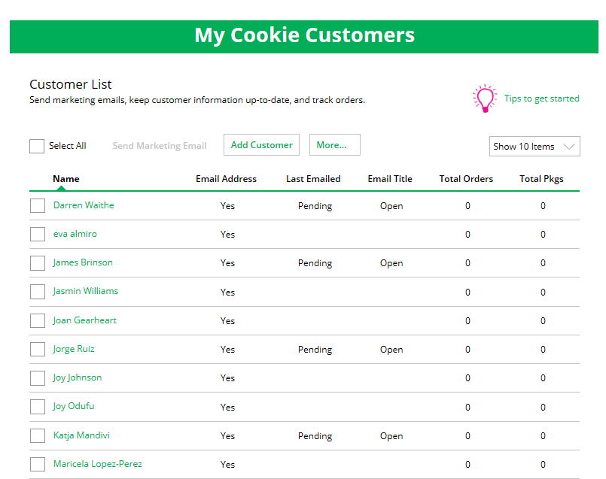
Connect with Customers

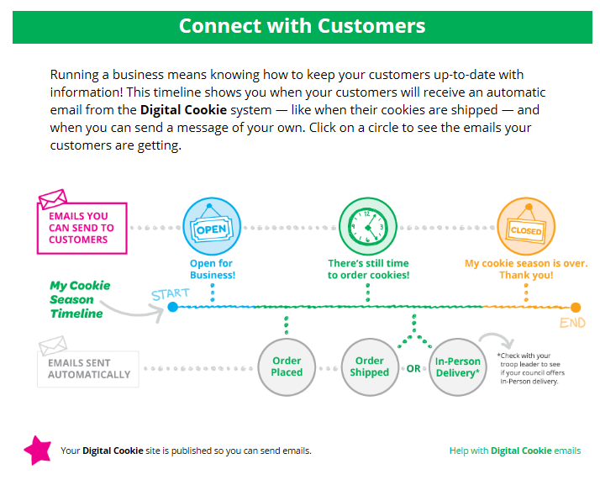


My Cookie Customers
Girls can add or import customers they want to send marketing emails to - and keep all of their customers in DOC for referencing in future cookie seasons.

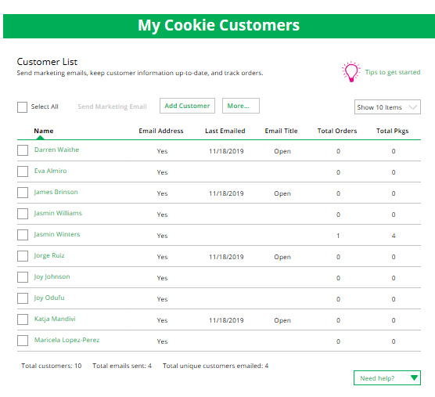
Encourage
Girls to add a “nickname” for their contacts like Grandma” or “Uncle”

Clicking on a customer’s name brings up more information about the customer, including details about any orders.

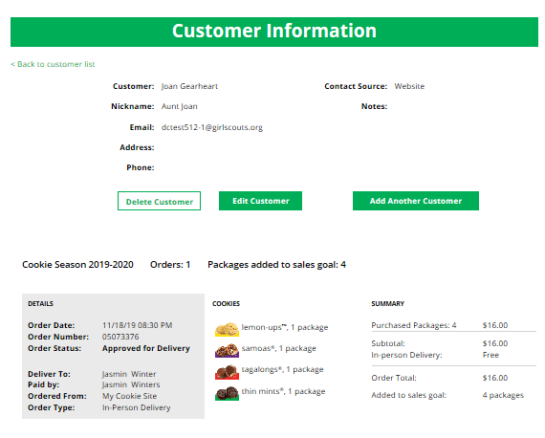

3a Send Marketing Emails
To send emails to your customers, simply check the box in front of all the customers you want to reach, then click “Send Marketing Emails.”

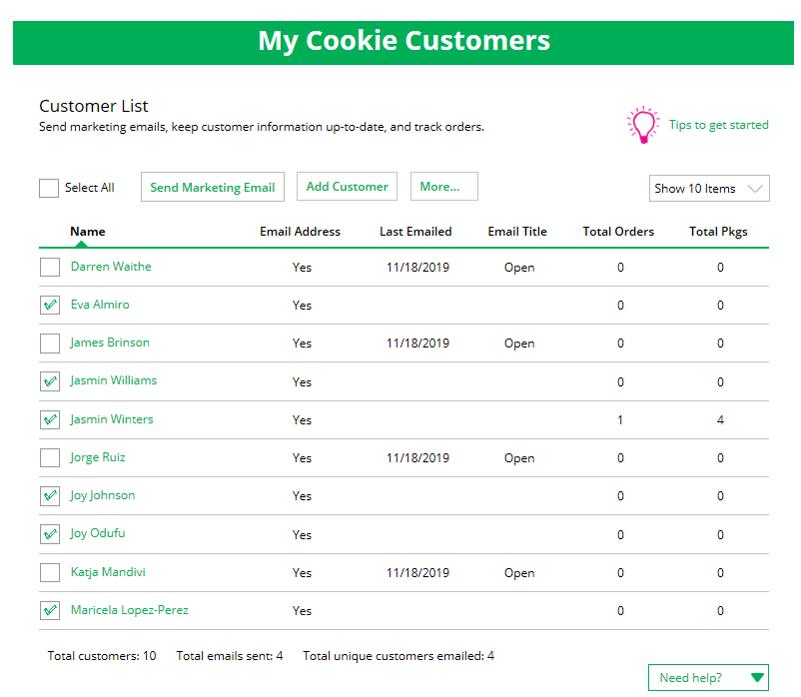
Select the customers.
Send Marketing Emails

Next, select which of the three emails you would like to send at this time:
“Open for business,” “There’s still time to order cookies,” or “Thanks for your support.”
To find out more about each of those emails and see a preview, go to the “Connect with Customers” section.

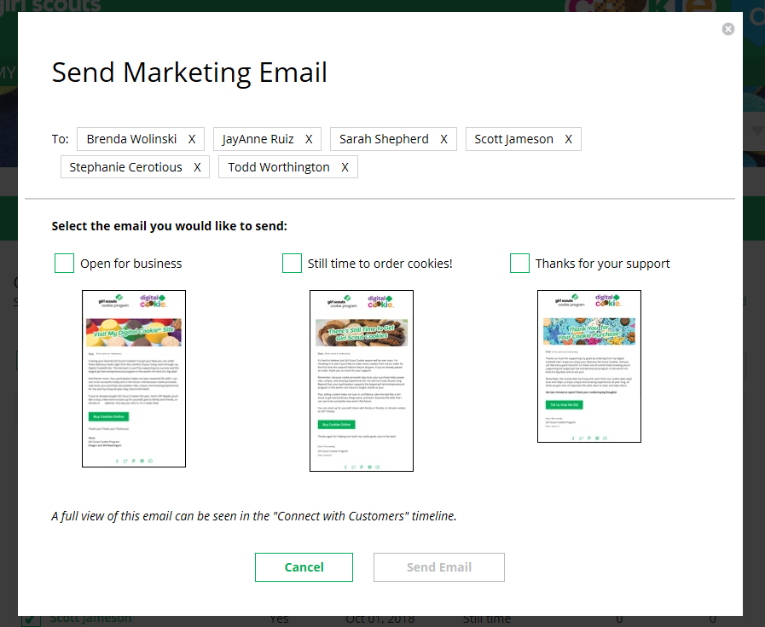
Check the box for your selection.

You can select different customers and send different emails to them or send the same email to all your customers at the same time.

When you have made your selection, check the box next to the email you are going to send and then click “Send Email” at the bottom.

3b Add Customer
To add customers manually (instead of importing), click the “Add Customers” button and you will get a screen for entering information.
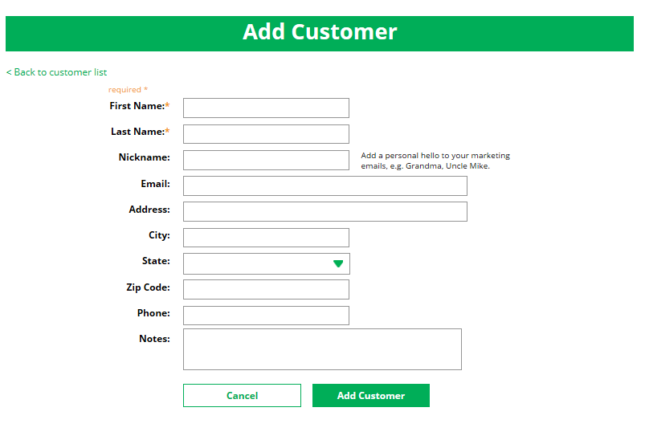

The only required field is name. However, to maximize your marketing, you should complete as many of the fields as possible. If you enter data in the “Nickname” field, the customer will receive their email addressed to the nickname instead of their first name.

When you are finished entering information, click “Add Customer”. The customer information will be stored.

If a girl attempts to add a customer that already has an email address in her customer list, the system will alert her that it is a potential duplicate and ask her what information should be maintained between the two records.
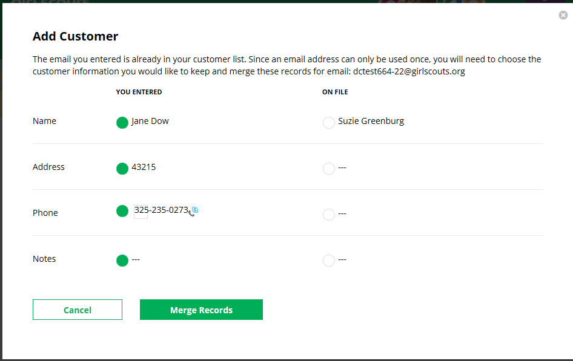

You can also add customers who have made a purchase and aren’t in your customer list. See the Parent Orders Tip Sheet for details.

3c Delete Customer
We recommend keeping customer lists from year to year, but there may be times when you will need to delete one or more. To do that, select the box in front of the customer(s) you want to delete, then click on the “more” dropdown menu and select “Delete Customer”.

You will get a pop-up warning that deletion is permanent and confirming how many customers you are attempting to delete. To continue with deletion, click “yes”
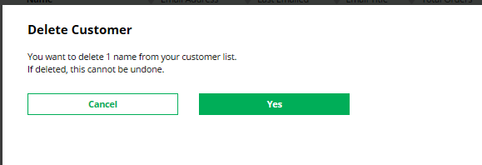

3d Import
Clicking on the “More” drop down menu gives you the option to import a customer list.
The screen has instructions on how to import contacts. It also includes the template that you will need for importing. The template is on the second tab in the spreadsheet, titled “Import_Customer.”

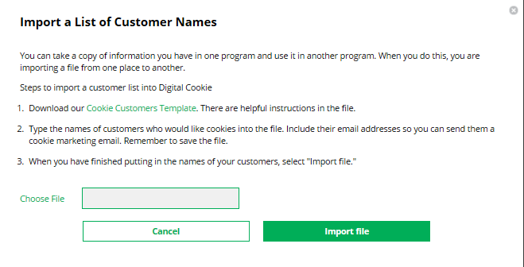

When the list is prepared and saved, use the “Choose File” button to select your file from where you saved it. Then click the green “Import File” button at the bottom. When it has successfully imported you can send marketing emails to those customers.

3e Export
The “More” drop down menu also gives you the option to export your customer list. When you choose “Export” a screen will pop up with instructions on how to export your customer list and save it to your computer.

Simply click the green “Export File” button and you will be asked where you want to save the file on your computer.
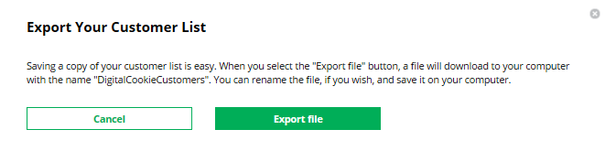


Connect with Customers
Learning about marketing to your cookie customers is a great skill that can increase cookie sales. In this section you can see the three different emails to send to your customers - and get suggestions for when to use them.

.
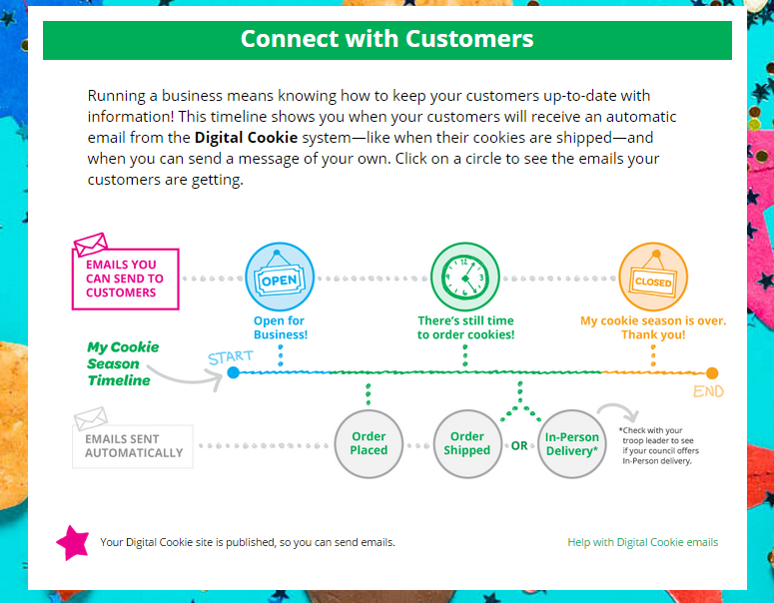
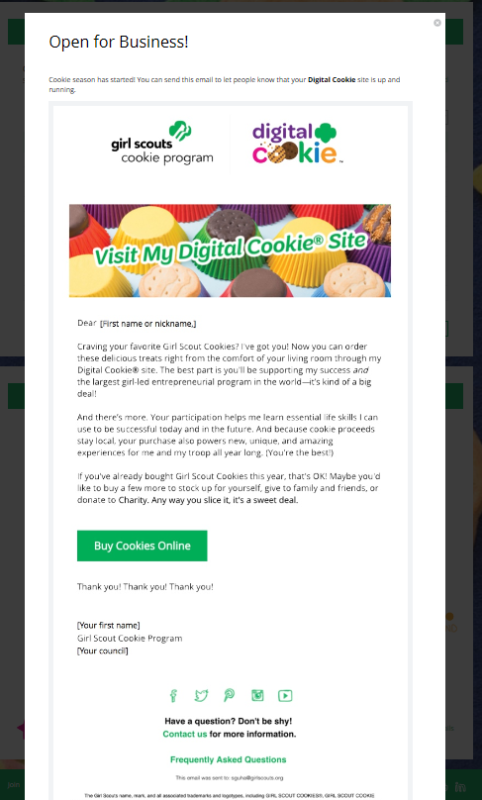

Preview of “Open for Business” email

Click on any of the circles to preview the emails you can send.


You can also send customers a link to your Digital Cookie Website directly from your home page.

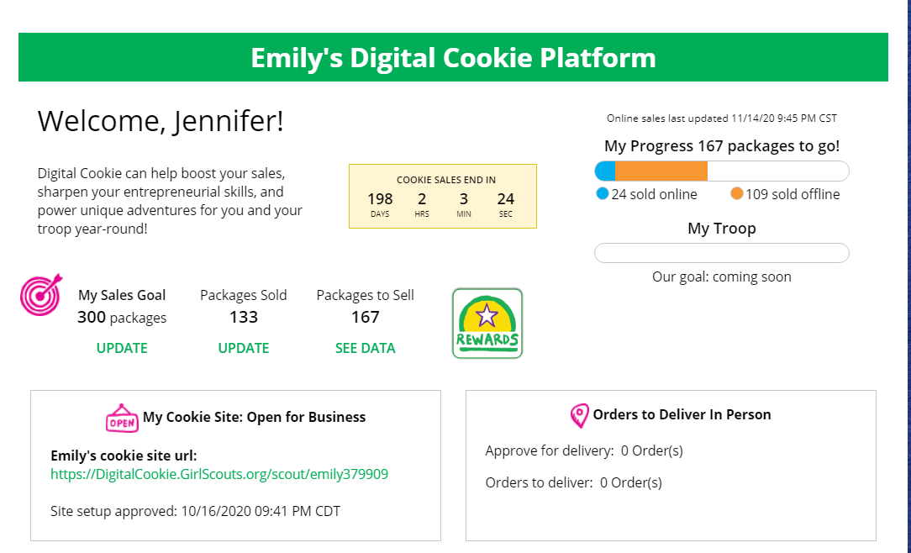

Customers who purchase directly from a link won’t be reflected as an email sent in your totals. But their orders are treated the same no matter how they reached your website.

